**Os lab Tasks**

**Eraj shakoor**

**33131**

**Bscs**

**Q1**

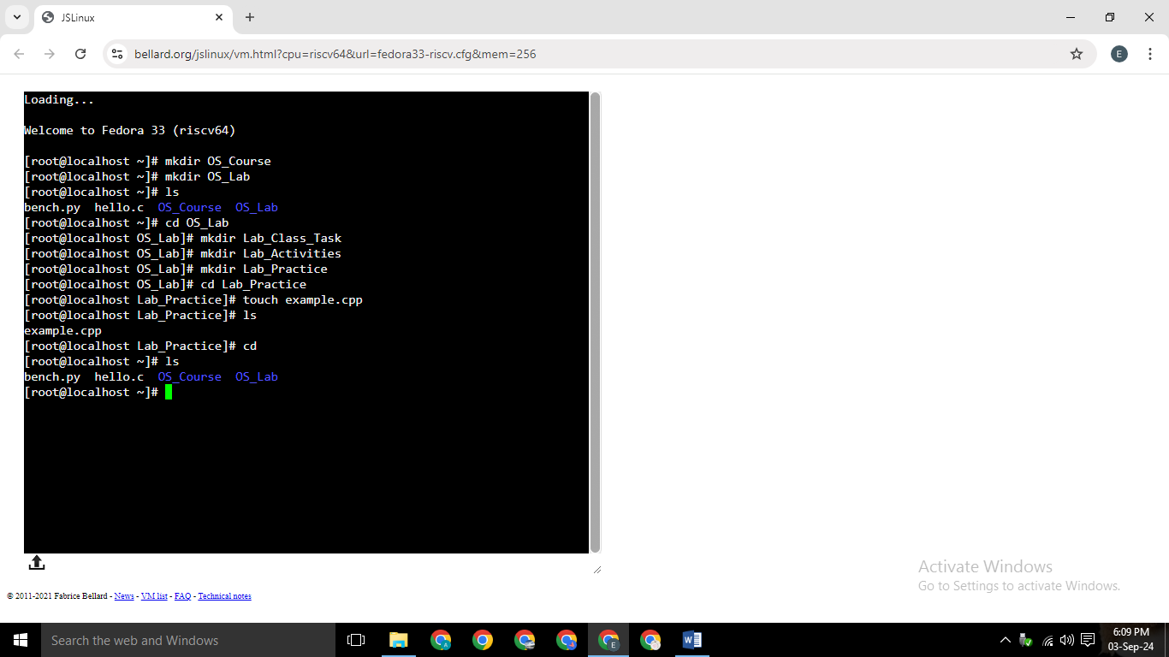

**Q2**

**Absolute vs Relative Paths**

**Absolute Path:**

An absolute path provides the complete address to a file or directory, starting from the root directory.

**Example:**

On Windows: C:\Users\YourName\Documents\Projects\Lab_Practice\file.txt

On Linux: /home/yourname/Documents/Projects/Lab_Practice/file.txt

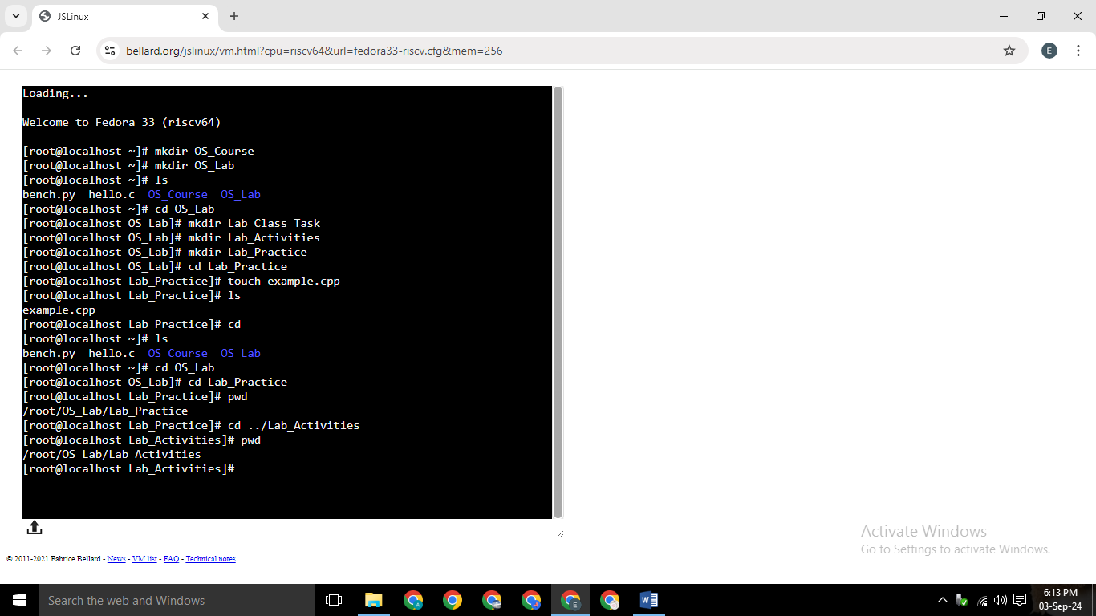

**Relative Path:**

A relative path gives directions to a file or directory starting from your current location (working directory).

**Example:**



**Q3**

When you press and hold the power button to turn off your computer, it shuts down immediately without going through the normal shutdown process. When you turn it back on, the computer starts up quickly because modern systems are designed to boot efficiently.

What happens there

**Hardware Check**: The computer quickly checks that all hardware is working (POST).

**Load System**: The BIOS or UEFI loads and starts the operating system.

**Fast Boot**: The operating system loads quickly, thanks to fast boot technologies that skip unnecessary steps.

**Login/ Desktop**: Finally, the login screen or desktop appears, ready for you to use.

Even after a forced shutdown, the computer is designed to start up smoothly by following these streamlined steps.